# Graphics applied

## Mobile phone App

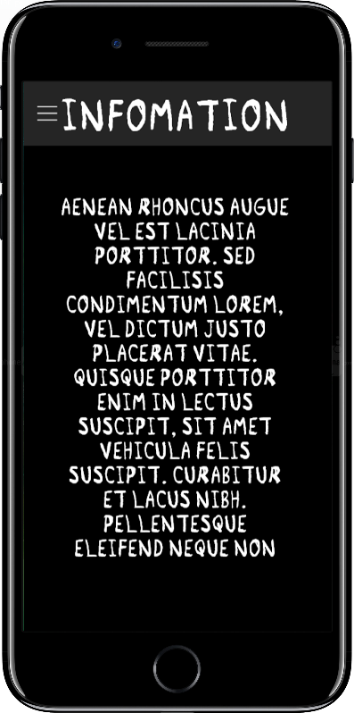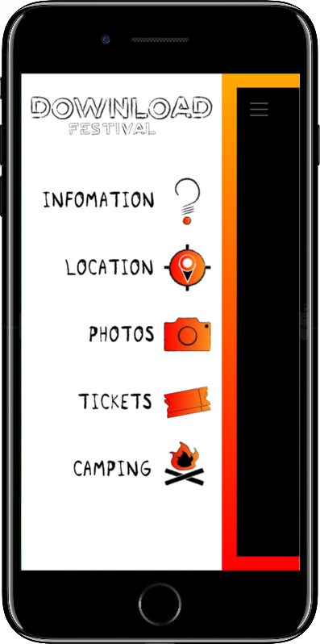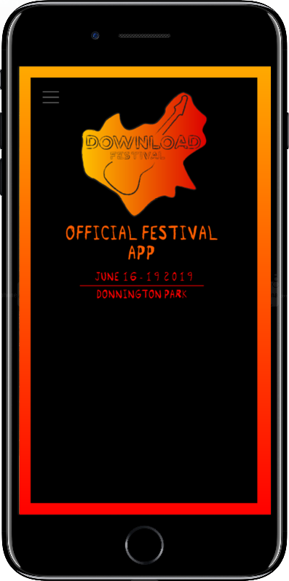

The icon graphics used on the menu for the phone icon worked well because they showed clearly what each section of the app would tell the user about, and paired with the text it allows the user to easily navigate their way around the app. The graphics were successful in this instance because if the user was unable to read the text but was able to see the icons, then they would still be able to navigate around the app. On the downside, the menu had to be coloured white, so the icons could be seen on the background, because they have black boarders meaning on a black background details would be lost such as the sticks on the camp fire. This means that the menu is a harsh white compared to the black background of the other pages.

The website was much more successful than the app. Firstly, the website has a large image on the background which links the festival to the type of music played at said festival, as the image depicts a famous musician. Secondly, the side menu was changed from white to dark red. On the app, the menu had to be coloured white so that the icons would show up. On the website, I chose dark red because its less jarring than going from dark colours to bright white, plus most of the detailing on the icons remain, and you can still see the camp fire sticks and most other detailing in black. Dark red also links to the other graphics better as they mainly consist of dark colours or red and oranges.

­

The poster was quite successful as it included all necessary details about the location and date, as well as a link to the website. The poster applies to the correct target audience through the use of reds, oranges and dark colours, and by using an image that has a famous musician which plays the type of music that’s going to be played at the festival, as the picture is from the festival itself.

The ticket would be too small to include the logo graphics; however, the image of the musician is used as a background image in this case. The image was made darker, so the text would stand out better making it easier to read, and the font and box colour is based on oranges linking it to the other graphics, app and website. The font isn’t exactly the same as on other products, however the font style linked with the image in the background clearly links it to the same festival.

Overall, I think the graphics I produced successfully rebranded the Download Festival. I think this for a number of reasons. One, the graphics apply to the target audience successfully, meaning the people who would be going to this festival would recognise the graphics and link them back to the style of music they listen to. If the festivals graphics did not link to the type of music being played at the festival, then people may not realise that the festival is targeted towards them as it doesn’t have the same style as other festivals targeted at them. the challenge here was to make the festival graphics both unique but also to be similar to other festivals so the target audience realise what type of festival it is. Secondly, the graphics are clear and do their job. the logo clearly says the name of the festival, while having a similar style to the other graphics produced so the graphics are similar enough, so people realise there from the same festival. the logo is clear to understand, and also has a subtle reference to the location of the festival. The icons are clear in their purpose and are easy to understand what they stand for and what their purpose is. Therefore, I think the graphics I produced successfully rebranded the Download Festival.